Here are a series of actors before they were famous. But who are these stars? To aid you in this process; row 1, 3 and 5 are Americans while 2 and 4 are British thespians.
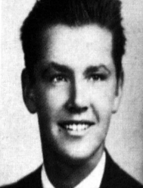 | 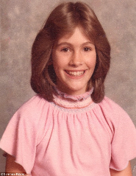 | 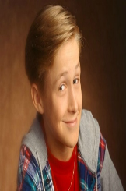 | 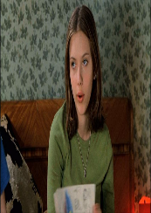
- Jack Nicholson | 2. Julia Roberts | 3. Ryan Gosling | 4. Scarlett Johansson
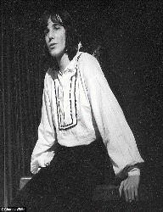 | 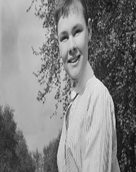 | 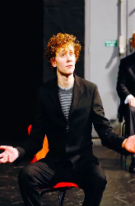 | 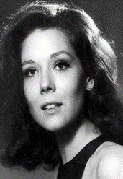
5. Daniel Day Lewis | 6. Judi Dench | 7. Tom Hiddleston | 8. Diane Rigg
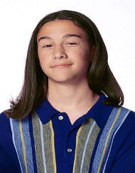 | 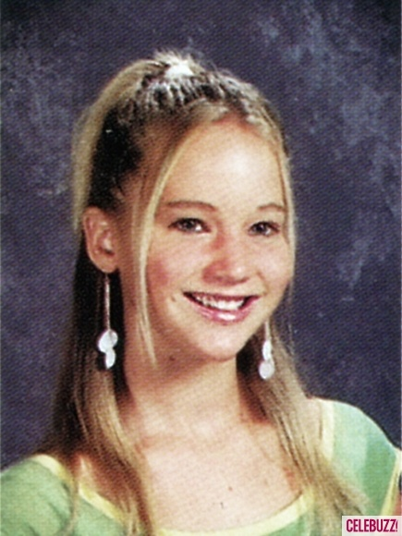 | 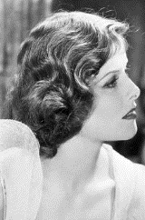 | 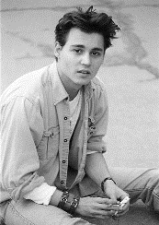
9. Joseph Gordon-Levitt | 10. Jennifer Lawrence | 11. Katherine Hepburn | 12. Johnny Depp
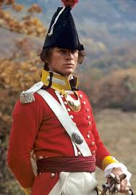 | 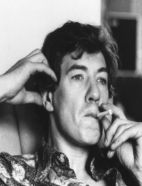 |  | 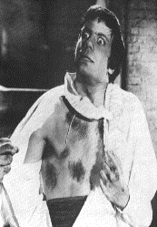
13. Daniel Craig | 14. Ian McKellen | 15. Helen Mirren | 16. Oliver Reed
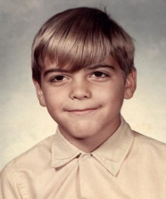 | 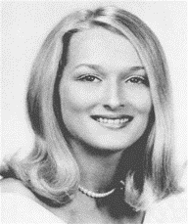 | 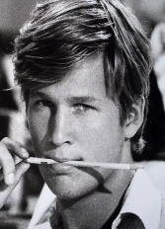 | 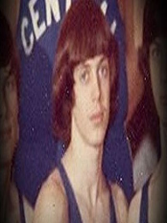
17. George Clooney | 18. Meryl Streep | 19. Jeff Bridges | 20. Steve Buscemi

